Web data extraction Requirement document

Suggested Code Policy:

1. Copy the Project folder structure from bellow github link.

<https://github.com/hackathonScrapping/BANK.git>

1. Use Python(Mandatory) with BeautifulSoup, Scrapy and Selenium (Feel free to use any other Python libraries)
2. Store Scrapped data with provided file name and CSV format.

Work 1:

**Scarped Data Format (File Name - BoI_Data_Deposit_<MM_DD_YYYY>.csv)**

|  |  |  |  |  |  |  |  |  |  |
| --- | --- | --- | --- | --- | --- | --- | --- | --- | --- |
| Date | Bank Name | Product Type | Product Name | Bank Offer | Account  Opening Balance | Minimum  Balance | Maximum Balance | Rate % | APY % |
|  |  | Online/Offline |  |  |  |  |  |  |  |
|  |  |  |  |  |  |  |  |  |  |
|  |  |  |  |  |  |  |  |  |  |
|  |  |  |  |  |  |  |  |  |  |
|  |  |  |  |  |  |  |  |  |  |
|  |  |  |  |  |  |  |  |  |  |

**OFFLINE OFFER**

[**https://personalbanking.bankofireland.com/app/uploads/2017/09/Customer-Deposit-Interest-Rates-Table-080917.pdf**](https://personalbanking.bankofireland.com/app/uploads/2017/09/Customer-Deposit-Interest-Rates-Table-080917.pdf)

**ONLINE ONLY OFFER**

[**https://personalbanking.bankofireland.com/app/uploads/2015/12/365-online-customer-rate-sheet-July-2017.pdf**](https://personalbanking.bankofireland.com/app/uploads/2015/12/365-online-customer-rate-sheet-July-2017.pdf)

**Checking or Current Account**

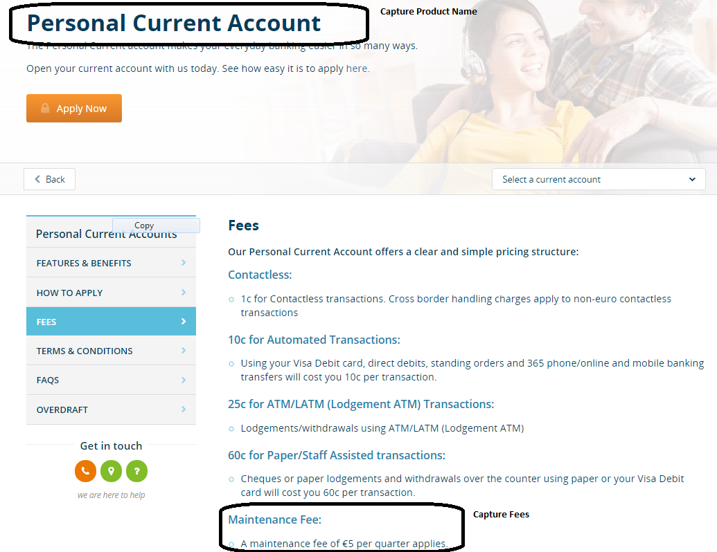

[**https://personalbanking.bankofireland.com/bank/current-accounts/personal-current-account/fees/**](https://personalbanking.bankofireland.com/bank/current-accounts/personal-current-account/fees/)

Work 2: Mortgage Rates

|  |  |  |  |  |  |  |  |  |  |
| --- | --- | --- | --- | --- | --- | --- | --- | --- | --- |
| Date | Bank Name | Product Type | Product Name | Loan amount | Mortgage Amount | Interest Tenor | Interest type | Rate % | APRC % |
|  |  | Online/Offline |  |  |  |  |  |  |  |
|  |  |  |  |  |  |  |  |  |  |
|  |  |  |  |  |  |  |  |  |  |
|  |  |  |  |  |  |  |  |  |  |
|  |  |  |  |  |  |  |  |  |  |
|  |  |  |  |  |  |  |  |  |  |

<https://personalbanking.bankofireland.com/borrow/mortgages/calculators/mortgage-calculator/?customer=No&segment=first-time-buyer>

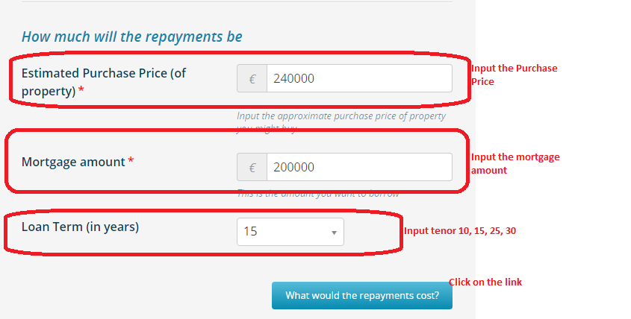

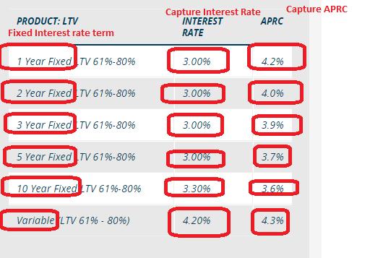

Repeat for 10, 15, 25, 30 year loan term